**Data Analytics and Business Intelligence**

**Exercise no.4**

**1)Solution**

Download and Install free R language from the following link. https://cran.r-project.org/bin/windows/base

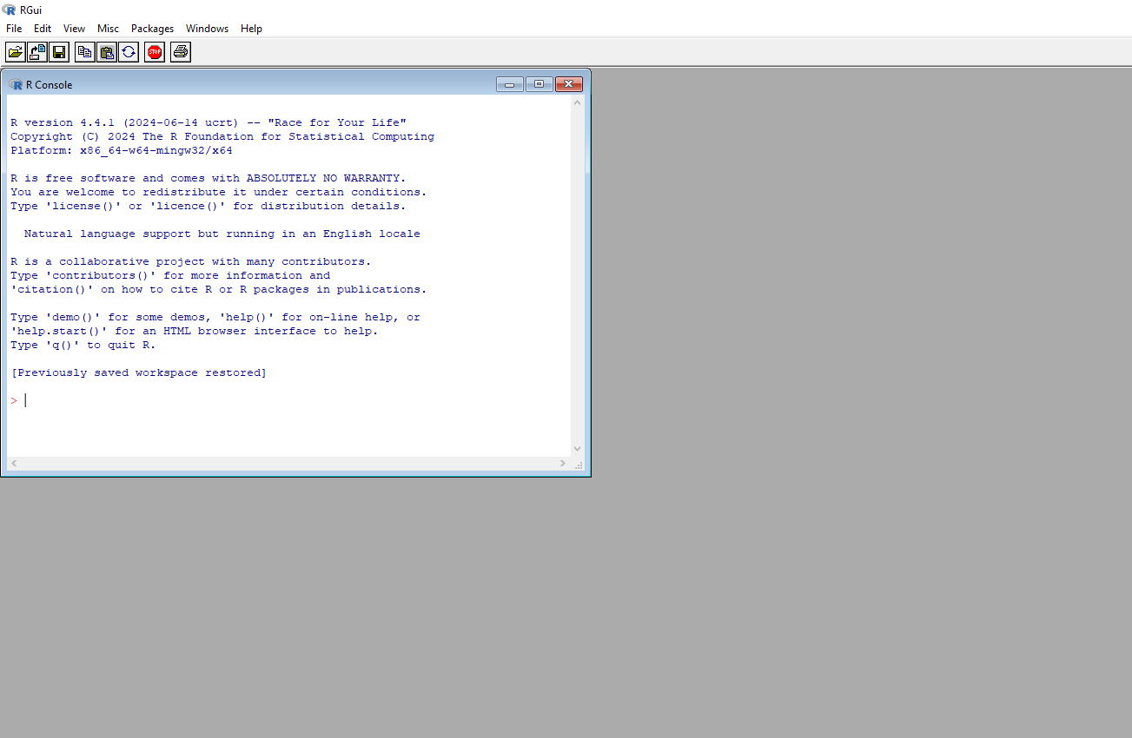

**2)Solution**

Install and import ggplot2 library in R GUI using the following commands. install.packages('ggplot2') library(ggplot2

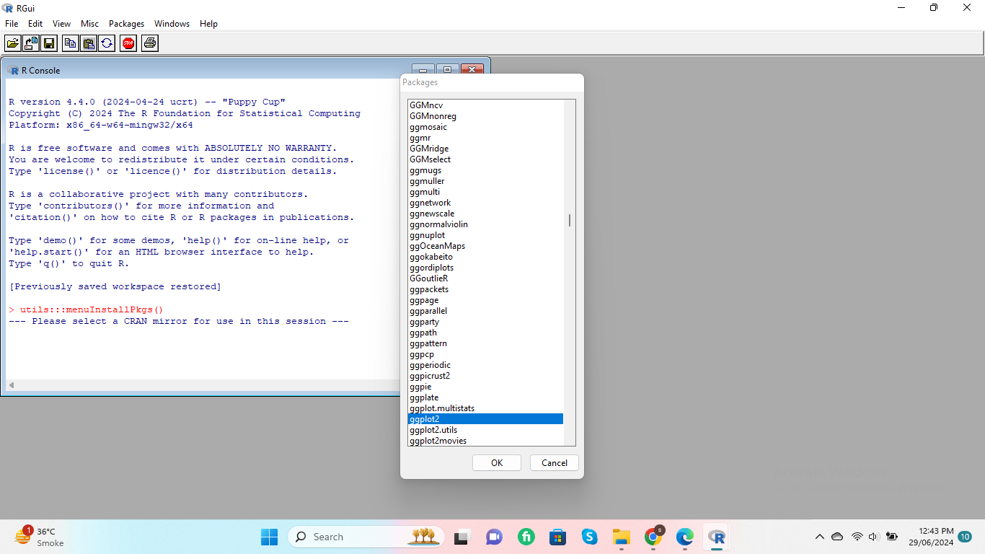

**3)Solution**

Create histogram for mpg column in mtcars dataset using the following command. ggplot(mtcars,aes(x=mpg)) + geom_histogram()

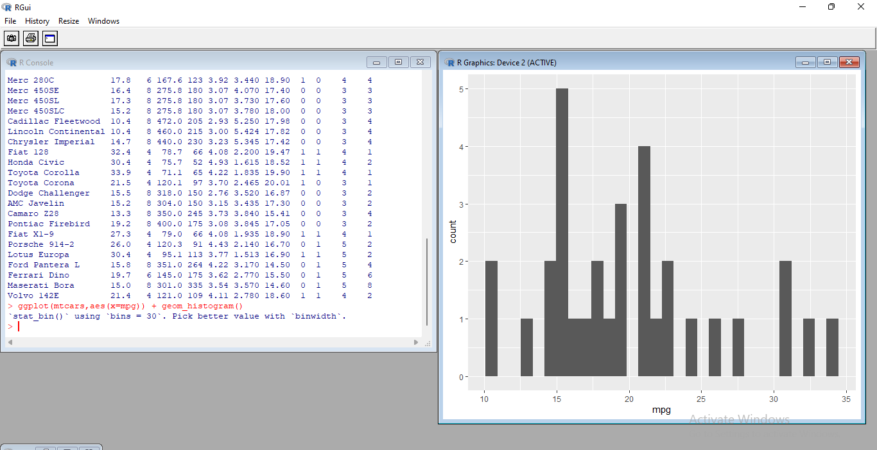

**4)Solution**

Create bar chart for gear column in mtcars dataset using the following command. ggplot(mtcars, aes(x = gear)) +geom_bar()

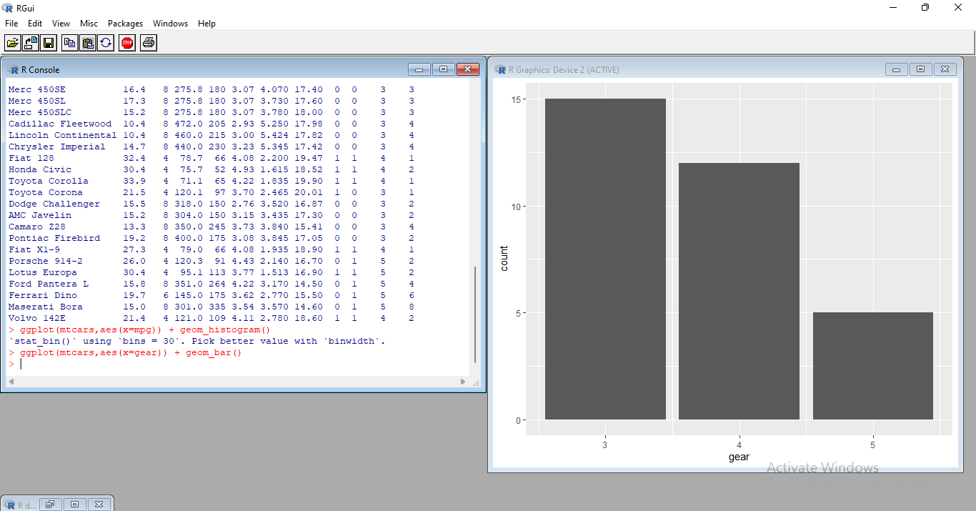

**5)Solution**

Create box plot for mpg column in mtcars dataset using the following command. ggplot(mtcars, aes(x=as.factor(cyl), y=mpg)) + geom_boxplot()

